Exercise 11

- Count the number of employees who have been with Bignet for four or more years.
SELECT COUNT(*) AS employees_4plus_years FROM employee_data WHERE yos >= 4;
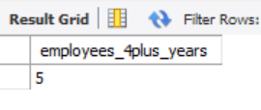
- Count employees based on their ages.
SELECT age, COUNT(*) AS count_of_employees FROM employee_data GROUP BY age;
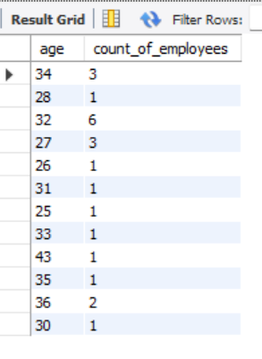
- Modify the above so that the ages are listed in the descending order.
SELECT age, COUNT(*) AS count_of_employees FROM employee_data GROUP BY age ORDER BY age DESC;
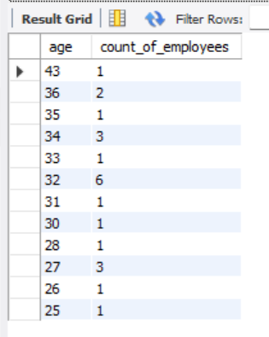
- Find the average age of employees in different departments(title).
SELECT title, AVG(age) AS average_age FROM employee_data GROUP BY title;
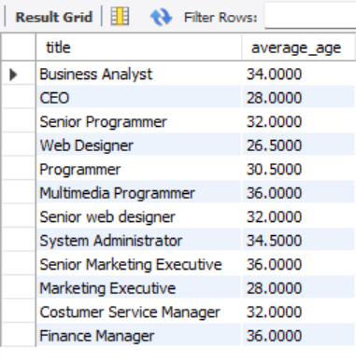
- Change the above statement so that the data is displayed in a descending order of average ages.
SELECT title, AVG(age) AS average_age FROM employee_data GROUP BY title ORDER BY average_age DESC;
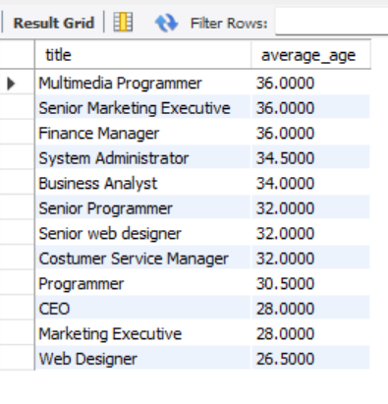
- Find and list the percentage perk(perk/salary x 100)for each employee with the % perks sorted in a descending order.
SELECT f_name,l_name,title, (perks / salary * 100) AS perk_percentage FROM employee_data ORDER BY perk_percentage DESC;
